Installing BERT in Rivanna, using the Huggingface Transformers library.
-Thanks to Digvijay Ghotane (Diggy) Graduate Fellow for DSPG 2021, who was able to find a fix for the library compatibility issues.
https://www.rc.virginia.edu/userinfo/rivanna/software/anaconda/
- Create a New Python Environment, with python version3.8
conda create -n <env name> python=3.8

- Activate your conda environment
conda activate <env_name>
- Install the nb_conda package that allows the environment to be accessed from within your Jupyter notebooks
conda install nb_conda
- Install PyTorch, which allows for the use of GPU for faster parallel calculations. You can find the correct command by selecting your system options on the website. https://pytorch.org/get-started/locally/
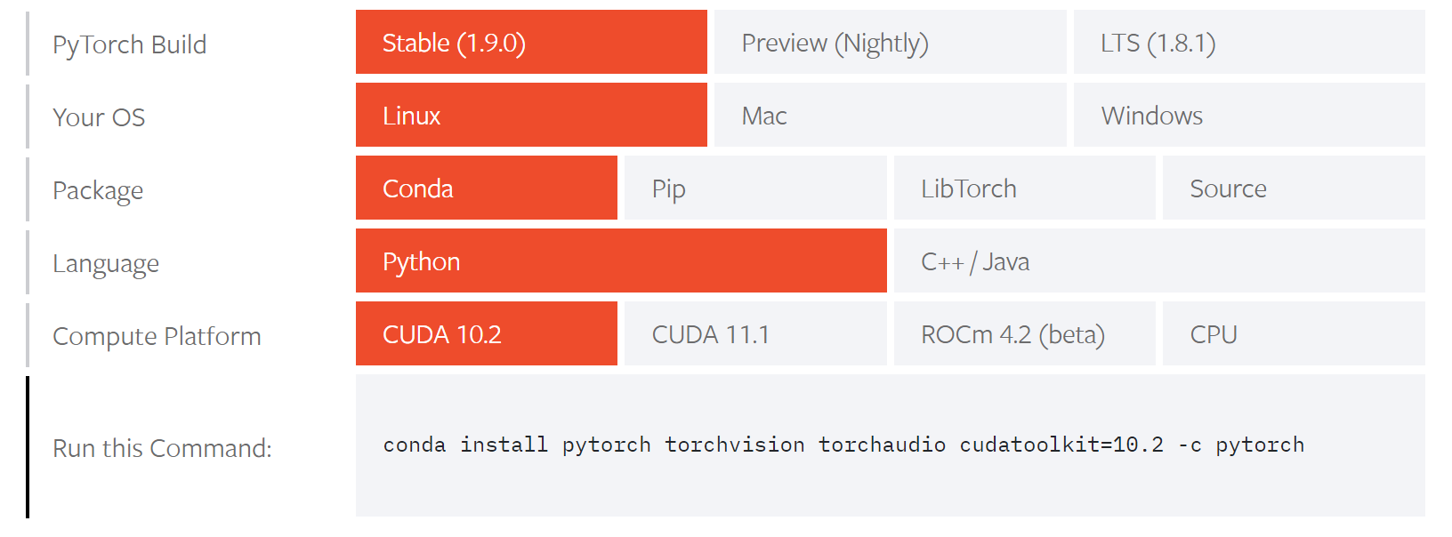
As we can see, the correct command is:

conda install pytorch torchvision torchaudio cudatoolkit=10.2 -c pytorch

- Install the transformers library.

conda install -c conda-forge transformers
(This is where I made an error in the morning. The command
conda install -c huggingface transformers
points to a version of the transformers library that’s too new to work well with the rest of Rivanna. The workaround is to use the older but stable conda-forge version of transformers)

- Install and Enable the Widgets library.
The sample code that I provide also includes a section where some new ML models get downloaded from the huggingface server. To show the progress bars for these downloads, you need to install ipywidgets
conda install -c conda-forge ipywidgets
Once this is installed, you’ll also need to run
jupyter nbextension enable --py widgetsnbextension

In the command line to enable access to jupyter to use these widgets.

Testing:
Start a new Rivanna session, and make sure you are using BII-GPU and specify at least 1 GPU in the session. You should be able to pick any of the GPU type options available in the drop down menu.

Start a Jupyter Notebook.
Select the new environment that you’ve been able to set up, in the top right of the Notebook (Select the Kernel that corresponds to the new environment you’ve set up)

Run the Following code:
import torch
device = torch.device("cuda")

from transformers import AutoTokenizer, AutoModelForTokenClassification
from transformers import pipeline
tokenizer = AutoTokenizer.from_pretrained("dslim/bert-base-NER")
model = AutoModelForTokenClassification.from_pretrained("dslim/bert-base-NER")
nlp = pipeline("ner", model=model, tokenizer=tokenizer)
example = "My name is Wolfgang and I live in Berlin"
ner_results = nlp(example)
print(ner_results)

If this isn’t working, please reach out and let me know so we can troubleshoot the issues.

